|  |  |
| --- | --- |
| Python programming  Laboratary (LCPIT-105) | |
| Practical file | |
| Submitted to: | Submitted by: | |
| Er. Harpreet Kaur Assistant Professor (IT)  GNDEC, Ludhiana | Brahamjot SIngh URN: 2303081  CRN: 2221146  Class: D2IT  Section: B2 | |

1. Data types, Operators and Expressions:

Experiment-1: The tax calculator program of the case study outputs a floating-point number that might show more than two digits of precision. Use the round function to modify the program to display at most two digits of precision in the output number.

* Program:

1. salary = float(input("Enter the salary: "))
2. tax_rate = 12.5
3. tax = (salary*tax_rate)/100
4. rounded_tax = round(tax, 2)
5. print("Tax is: ", rounded_tax)
6. print("Salary after tax is: ", salary - rounded_tax)

* Output:

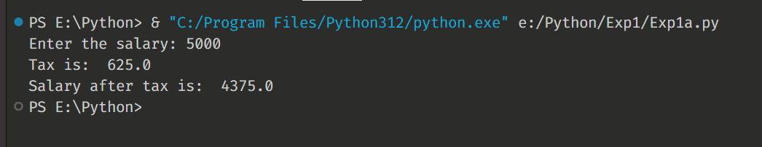

_________________________________________________________________________________

Experiment-1: You can calculate the surface area of a cube if you know the length of an edge. Write a program that takes the length of an edge (an integer) as input and prints the cube’s surface area as output.

* Program:

1. edge = int(input("Enter the length of edge of cube: "))
2. surface_area = 6*edge**2
3. print("Surface area of cube is: ", surface_area)

* Output:

